Meeting Minutes #
DATE: March 20 2025
TIME: 60 mins (12:00-1:00)
LOCATION: 1A18

Meeting called by | Bashu
Type of meeting | Biweekly Meeting
Minutes taken by | Sara
List of attendees | Sara, Bashu, Anukul, Asutosh, Parvaneh
List of absentees
Excuses
Agenda | - E3MT Debrief  - Plan for future events
Content | - E3MT Debrief  - Judges gave some good feedback (screenshot attached)  - Financial Update (Table attached)  - Plan for future events  - Summer lunch (June 1st week)  - EGRC (July last week)  - Next committee election (August 1st week)  - Handover to next committee (August last week/September 1st week)  - Election candidate can’t stand if they are graduating in 6 months. (talk to Candace)

Screenshots:

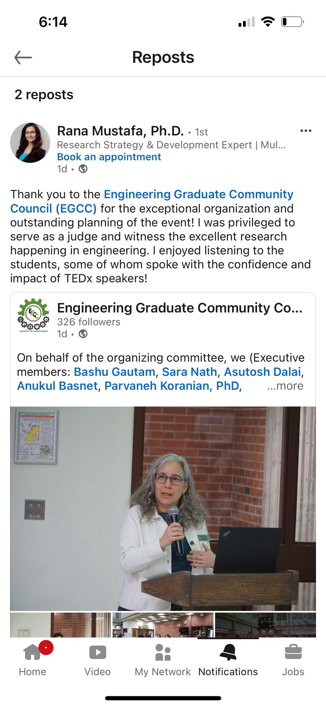
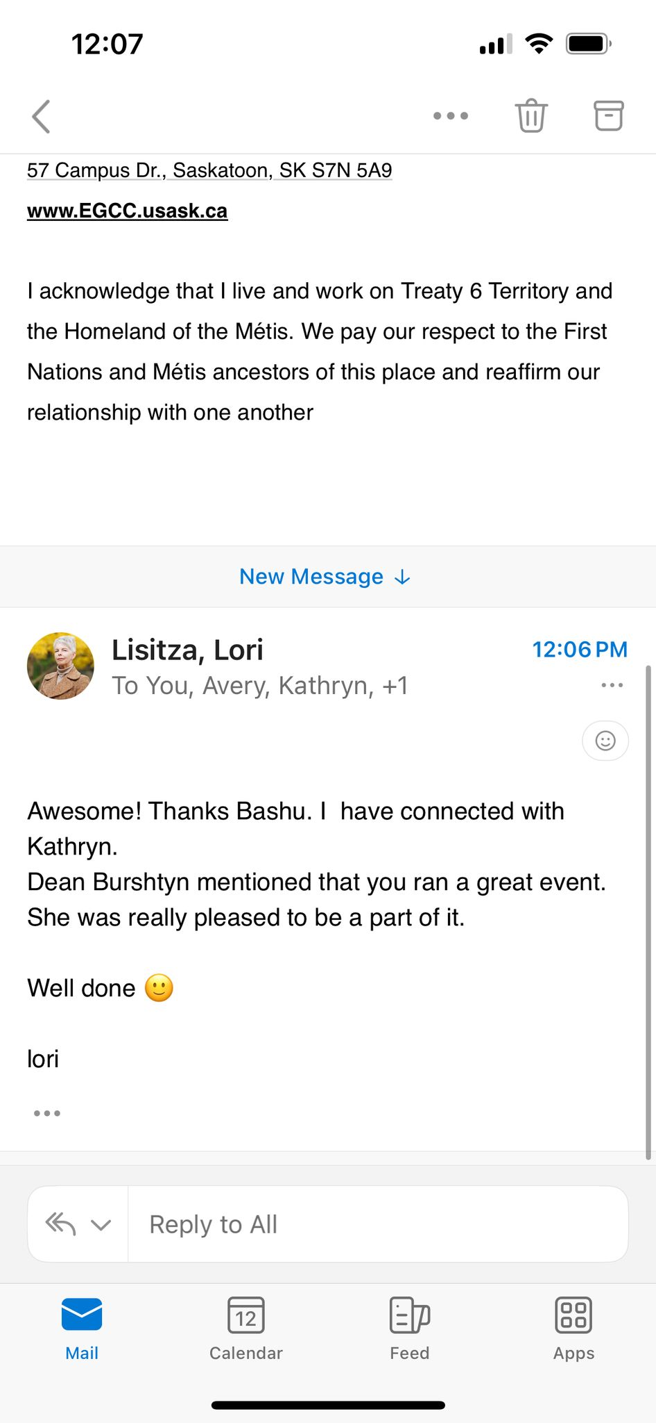
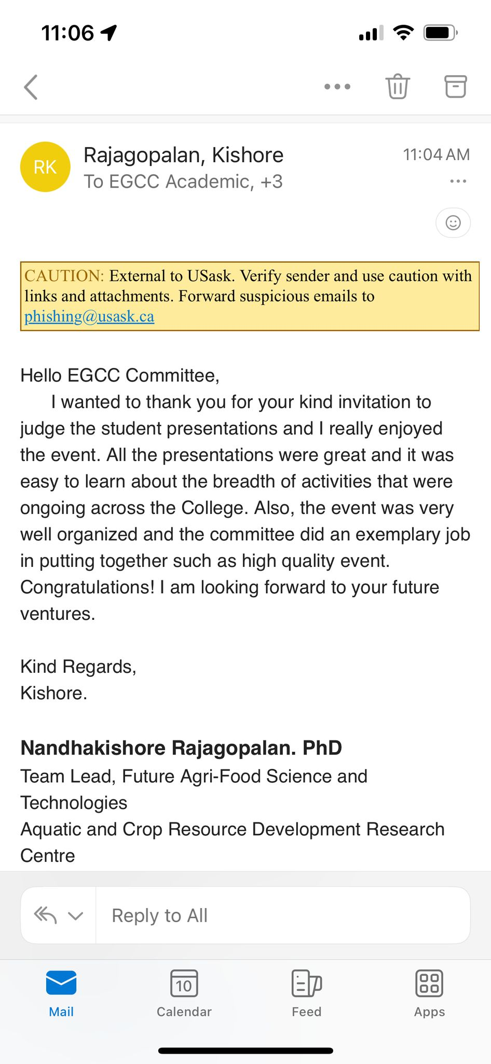

EGCC FINANCIAL REPORT - [2024-2025]
Title |  | Expense ($) |  | Member |  | Date |  | Status
Christmas Lunch
 | Costco | 161.48 |  | Bashu |  | Dec.17, 2024 |  | Reimbursed
 | Soft Drinks | 20.03 |  | Bashu |  | Dec.17, 2024 |  | Reimbursed
 | Tim Hortons | 61.98 |  | Bashu |  | Dec.17, 2024 |  | Reimbursed
 | Pizza | 882.09 |  | Bashu |  | Dec.17, 2024 |  | Reimbursed
 | Total Expense for Lunch | 1125.58
E3MT Competition
 | Podium | 72.9 |  | N/A |  | Jan.22, 2025 |  | Paid
 | Parking | 31.5 |  | Bashu |  | Feb.26, 2025 |  | Reimbursed
 | Parking | 31.5 |  | Bashu |  | Feb.28, 2025 |  | Reimbursed
 | XL Printing | 14.66 |  | Bashu |  | Feb.28, 2025 |  | Reimbursed
 | XL Printing | 20.64 |  | Bashu |  | Feb.28, 2025 |  | Reimbursed
 | XL Printing | 14.66 |  | Bashu |  | Mar.04, 2025 |  | Reimbursed
 | Pizza | 908.29 |  | Bashu |  | Mar.03, 2025 |  | Reimbursed
 | Soft Drinks | 77.15 |  | Bashu |  | Mar.03, 2025 |  | Reimbursed
 | Dollarama - 57 Pens | 198.14 |  | Bashu |  | Mar.03, 2025 |  | Reimbursed
 | Staples - Lanyards | 20.84 |  | Bashu |  | Mar.03, 2025 |  | Reimbursed
 | Tim card gifts and drink | 484.9 |  | Bashu |  | Mar.05, 2025 |  | Reimbursed
 | Mugs and bags | 240.24 |  | Parvaneh |  | Mar.06, 2025 |  | Reimbursed
 | Gas price and Parking | 61.86 |  | Anukul |  | Mar.08, 2025 |  | Reimbursed
 | 1st Prize | 400 |  | N/A |  | Mar.07, 2025 |  | Paid
 | 2nd Prize | 300 |  | N/A |  | Mar.07, 2025 |  | Paid
 | 3rd Prize | 200 |  | N/A |  | Mar.07, 2025 |  | Paid
 | 4th Prize | 150 |  | N/A |  | Mar.07, 2025 |  | Paid
 | 5th Prize | 100 |  | N/A |  | Mar.07, 2025 |  | Paid
 | Total Expense for 3MT | 3327.28
Title |  |  | Income ($) |  | Date |  | Status
Account balance in Aug.2024 |  |  | 2591.02
including | Sigma- Silver Sposor-2years |  | 2000 |  | 2024 |  | Received
EAT
 | Reimburse |  | 1125.58 |  | 18-Feb |  | Received
 | Gold Sponsor-E3MT |  | 2500 |  | 5-Mar |  | Received
 | Gold Sponsor-EGRC Conference |  | 1374.72 |  | 12-Mar |  | Received
College of Engineering
 | Gold Sponsor-EGRC Conference |  | 2500 |  | 12-Mar |  | Received
Opus
 | Silver Sposor - E3MT |  | 1000 |  | _ |  | _
CGPS
 | Reimbursement |  | 1000 |  | _ |  | _
GSA
 | Reimbursement |  | 500 |  | _ |  | _
 | Reimbursement |  | 250 |  | _ |  | _

Balance as of 20 March 2025 = $8116.46

